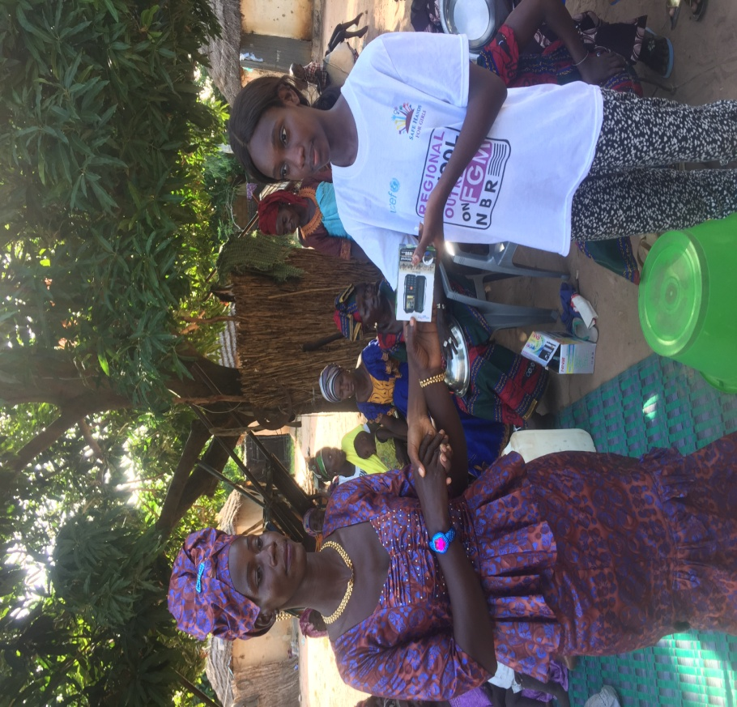
Handing over of telephones to radio listening groups

Organized by Safe Hands for Girls

SEPTEMBER 13TH 2016

NORTH BANK REGION, THE GAMBIA

CONTENTS

Acknowledgement

Executive summary

Introduction and Background

Highlights of the Report

Acknowledgement

We wish to extend our sincere gratitude to Mr Dibba, Saidykhan and the residents of North Bank Region as the initiators of this activity.

Furthermore, we thank the women Kafoos who had the courage to step up and join the fight to end this dreadful practice.

Special thanks to the Safe Hands for Girls representatives for successfully coordinating this activity.

Executive Summary
Safe Hands for Girls is a survivor led women’s organisation that aims to eradicate Female Genital Mutilation and all other forms of Gender Based Violence through advocacy programs, trainings, workshops and community outreach, as well as to provide support to women and girls who are survivors. Safe Hands for Girls was established in 2013 with offices in the U.S. and The Gambia.

Introduction and Background

Female Genital Mutilation (FGM) is one of the main forms of harmful traditional practices that are deeply rooted in The Gambia. Gambian statistics have shown that Female Genital Mutilation is still prevalent in The Gambia. According to the MICS 2010 report, 78.2% of the women that were interviewed reported that they would like their daughters to undergo the practice. Education and ethnicity plays an important role on the type of people who practice FGM. Women with no education (78.5%) are more likely to approve of the practice than their peers with secondary education (59%).

As a result, Safe Hands for Girls and its partners decided to come up with an activity wherein members of the community will use the media to disseminate information while listeners of the said program will also call to participate and share experiences. Safe Hands donated Radios, Mobile Phones and USB sticks to facilitate the dissemination of information in the community.

This project is geared toward bringing together women from different backgrounds to facilitate their fight against Female Genital Mutilation.

Highlights of the Report

The first village visited in the North Bank Region was KUNJO where a total of approximately 45 women were gathered. Upon our arrival we were warmly received and the reception was outstanding. The women sang and danced to make us feel at home. Sainey Dibba introduced the team from SHfG briefly. He further mentioned that the whole idea of the initiative is to give them the platform to discuss internally with regards to issues of FGM be it in the farmlands or gatherings of similar sort. He made it known to them that radios, usb sticks and mobile phones are being donated to them to facilitate their programs on FGM.

Mass Laye from SHfG thanked the women sincerely assured them of Safe Hands for Girls continuous support as long as they contribute significantly to the fight against FGM.

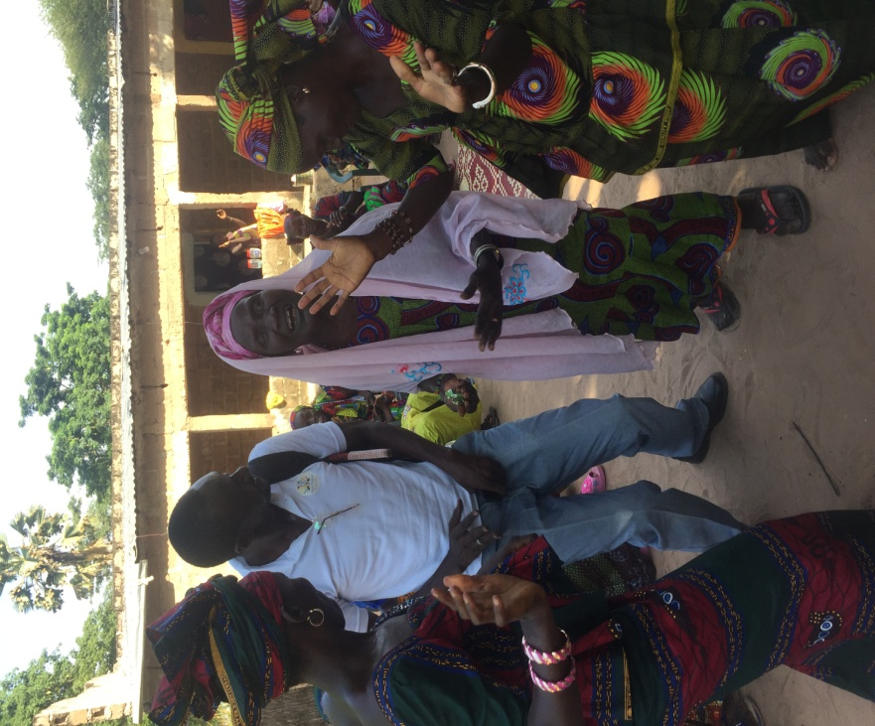

Sainey Dibba later introduced Marie Jeng who expressed how happy she was and urged them never to relent in saving the babies. She congratulated them for stepping up when many others have been reluctant. Marie Jeng finally handed over the mobile phone to the president of the kafoo and they all rejoiced.

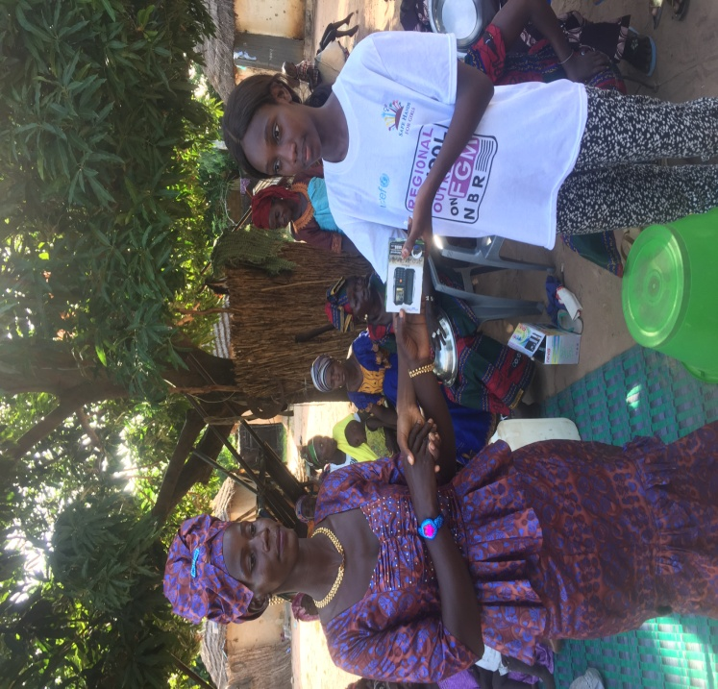

One of the oldest women in the Kafoo thanked the team and emphasized that they have stopped the practice because the law discriminates against it and even society. They have also realized the harm it can cause their daughters. She made mention that our coming there is important to them because the issue at stake is as important to them as it is to us.

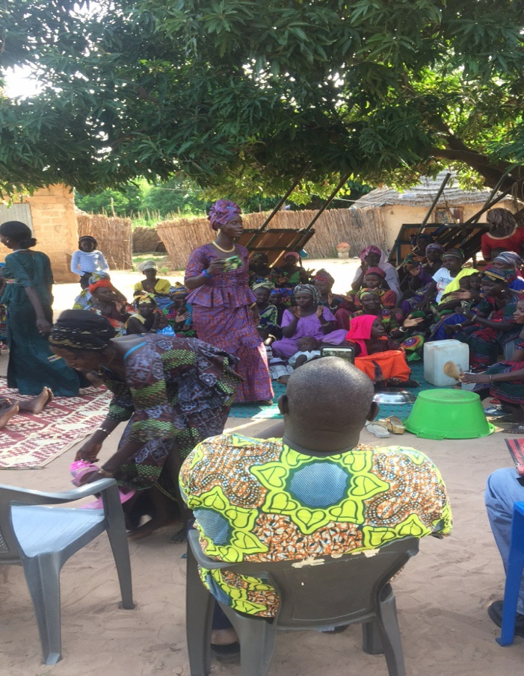

The second village visited was farafenni were approximately 40 women were reached.
The welcoming was very formal and dull due to a tragedy that had just occurred in their community, We began with prayers, followed by an introductory remark by Mr Sainey Dibba.

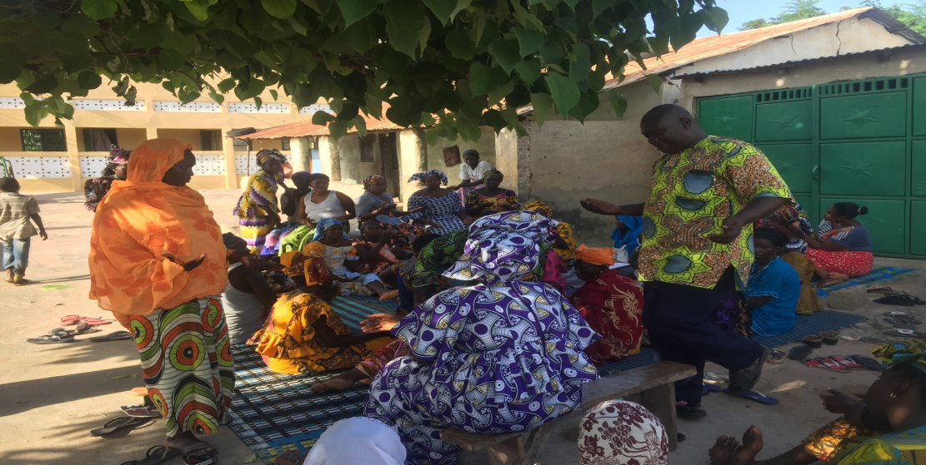

Mr Dibba who served as the Chairperson thanked the women and the team from Safe Hands, he further stated that the purposed of the meeting was to introduce the organization who are the sponsors of the aforementioned activity, He reminded them that the purpose of the program is for communities to take the lead in the advocacy process, hence why the group was trained on the health complications of the practice of FGM.

Mass Laye the Program and outreach officer for SHFG thanked Mr Dibba, Saidykhan and the group for the initiative. He assured them the organization would continue to support as far as ending FGM is concerned. He reminded them that FGM can be eliminated through awareness raising, education, advocacy and partnership with the communities as the fight remains a collective effort. Mr Laye thanked them once again and came together to pray for the departed soul to Rest in Peace.

