Garden Seeds Handing Over to Farafenni Radio Listening Groups.
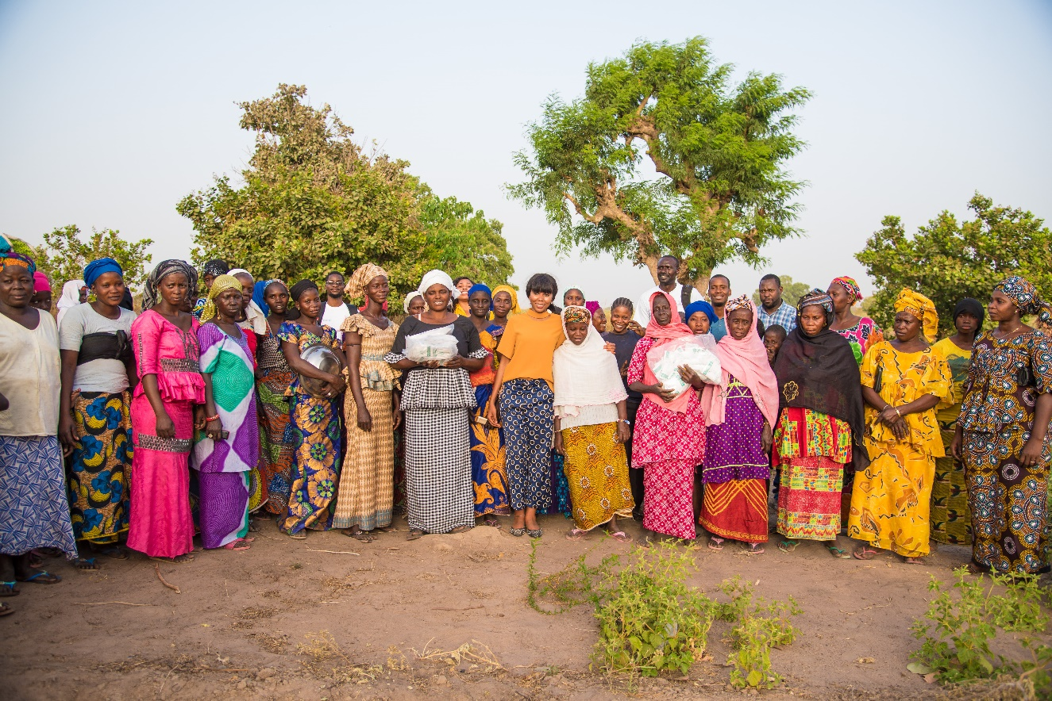

Venue: KUNJO WOMEN GARDEN
5th March 2018

This activity was organized by the SHFG in collaboration with partners in the NBR.

Contents
Acknowledgment
Executive Summary
Introduction and Background
Highlights of Report

Acknowledgement
We wish to extend our sincere gratitude to Mr Dibba and the residents of North Bank Region for the warm welcoming.

Furthermore, we thank the women Kafoos who continue to step up in the fight to end this dreadful practice called FGM.

Special thanks to the Safe Hands for Girls representatives for successfully coordinating this activity.

Executive Summary

Safe Hands for Girls is a survivor led women’s organisation that aims to eradicate Female Genital Mutilation and all other forms of Gender Based Violence through advocacy programs, trainings, workshops and community outreach, as well as to provide support to women and girls who are survivors. Safe Hands for Girls was established in 2013 with offices in the U.S. and The Gambia.

Introduction and Background
Female Genital Mutilation (FGM) is one of the main forms of harmful traditional practices that are deeply rooted in The Gambia. Gambian statistics have shown that Female Genital Mutilation is still prevalent in The Gambia. According to the MICS 2010 report, 78.2% of the women that were interviewed reported that they would like their daughters to undergo the practice. Education and ethnicity play an important role on the type of people who practice FGM. Women with no education (78.5%) are more likely to approve of the practice than their peers with secondary education (59%).

The purpose of this activity was to hand over garden seeds to the Radio listening groups in NBR, these radios listening groups consist of women from various ethnicities whom have been working with Safe Hands for Girls through our focal person in the North Bank Region – Mr Sainey Dibba in the campaign against FGM & Child Marriage. These seed donations were a token of appreciation for the immense contribution of the women kafoos in the fight to end FGM in their community.

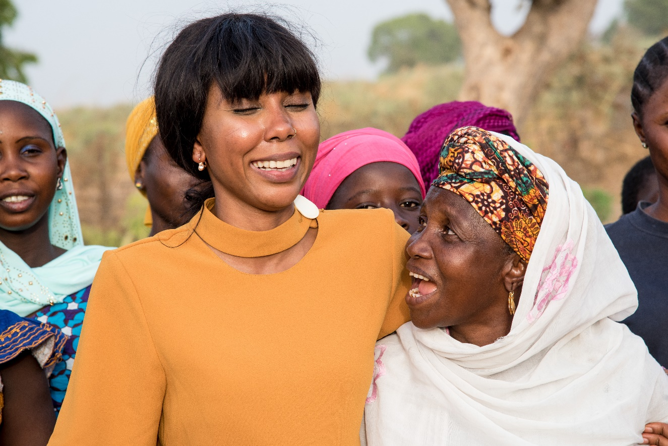

Highlights of Report
The team were welcomed by the women at the garden with drums, dancing and singing which was marvellous.
Mr. Dibba opened the meeting with prayers and reminded the women of the promised made by SHFG, he further jogged their memories on the radios and telephones that were given to them and its importance. The radios help to facilitate awareness raising on gender issues affecting women and girls, the telephones are used to communicate and contribute to the radio programs concerning women and girls. Mr Dibba concluded on his speech by calling upon on Mr. Modou Lamin Davis the program officer for communication at SHFG to introduce each member of the team by name and role.
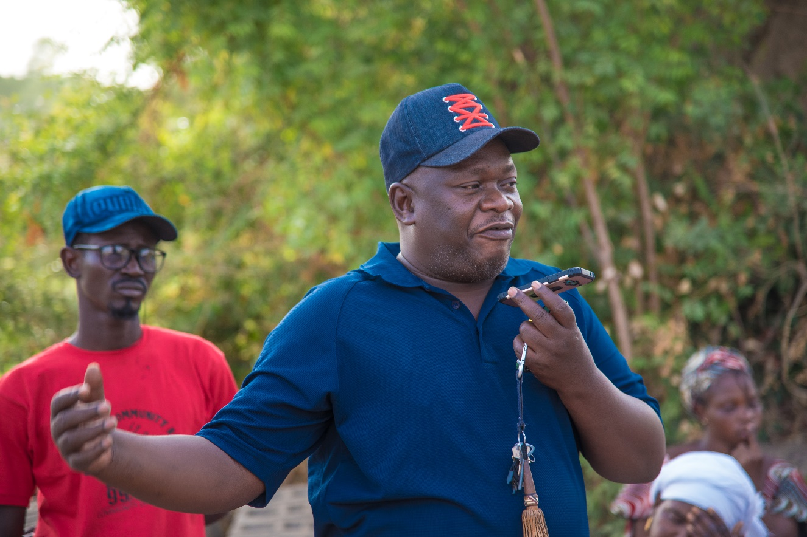
Mr Dibba (Blue Shirt)
We were then taken for a tour of the garden, the women told the Executive Director Jaha Dukureh about the constraints that affect them in the garden such as fencing and water supply issues, animals usually break through the wooden barrier protecting the garden and destroy their crops.
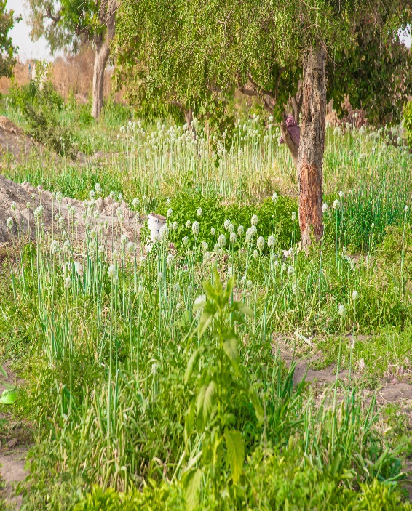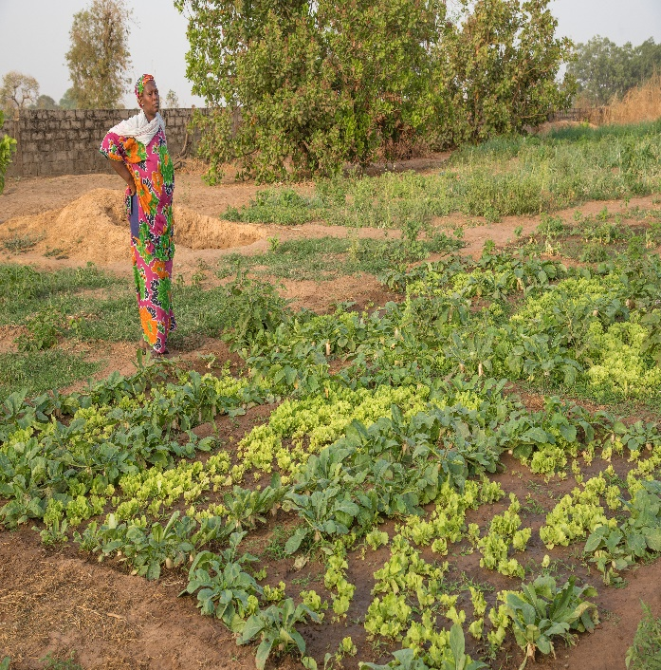
Garden
SHFG fulfilled their earlier promise to the radio listening groups by handing over variety of crop seeds to the garden women. The garden is approximately 275m by 135m square, with 13 Wells and a broken borehole.
The wells are shallow and they occasionally dry up due to the demand for water and size of the garden.
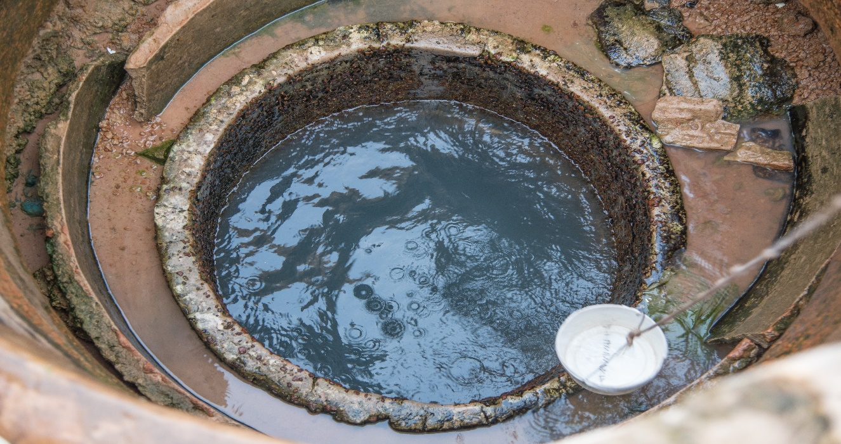
Jaha thanked the women for their amazing work and urged them to stick together and support the young girls as she is working with organisations that have the best interest for girls at heart and promised to do her utmost best to support the women with their garden.
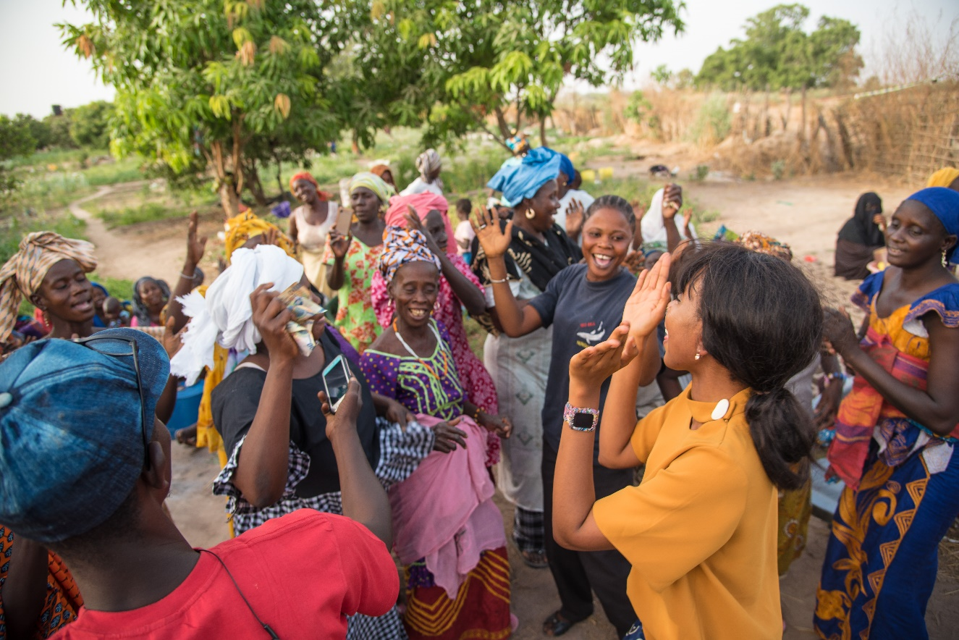
The women comprise mainly of three ethnicities. The Mandinka Group of Farafenni, the Wolof and the Sererr groups of KUNJO Village. These groups consist of women under the child bearing age and older women, widows and school going boys and girls, the women mentioned the garden is their sole source of income the women thanked Jaha and the group for their support.

