|  |
| --- |
|  |
| THE REPORT ON THE REGIONAL SCHOOL OUTREACH ON FGM. |
| Organised by Safe Hands for Girls in Partnership with Human Dignity Foundation. |
|  |
|  |
| Date: 2nd-9th May, 2016  Venue: Kanifing Municipality |

**Funded by Human Dignity Foundation**

|  |
| --- |
|  |

**Acknowledgement**

The Regional School Outreach on FGM implementation and organizing team wishes to express appreciation to everyone who contributed towards the success of the outreach. We wish to express sincere appreciation to the following institutions and individuals for their valued contributions both collectively and individually towards the materialization of this activity.

* We are highly indebted to Human Dignity Foundation for the financial and moral support towards the success of this outreach.
* We highly appreciate the assistance of the facilitators, volunteers and resource persons for being very useful in meeting the target of the outreach.
* We wish to extend our appreciation to the School administrations and journalists from all parts of region one for their participation in the outreach and their interest in working towards total eradication of FGM in The Gambia.
* Special thanks and appreciation go to the members, staff and volunteers of Safe Hands for Girls, for their individual and collective contributions toward this outreach.

Lastly, we wish to thank Wilson F. Okoi and Maria Saine of Safe Hands for Girls for compiling this report.

**Table of Contents**

**1. Executive Summary**

**2. Kanifing Municipality Regional School Outreach on FGM**

**2.1. Session one: Health Effects on FGM**

**2.2. Session two: Law on FGM & Legal Implications of FGM**

**2.3. Session three: Child Protection & FGM**

**3. Annex one: Pictures During the Regional School Outreach**

**4. Annex two: List of Volunteers**

**5. Annex three: Way Forward**

**Executive Summary**

Safe Hands for Girls (SHfG) is a survivor led women’s rights organization that aims to eradicate Female Genital Mutilation (FGM) and all other forms of gender based violence through awareness-raising, advocacy, youth empowerment, and community outreach.

One key area that has been our main concentration has been Female Genital Mutilation (FGM) in The Gambia. Female Genital Mutilation is a practice which has led and continues to result to a numerous number of complications for women as well as a violation of their fundamental human rights.

Gambian statistics have shown that Female Genital Mutilation is still prevalent in The Gambia with religion being one of the major reasons behind the practice. Government efforts to bring an end to FGM have been recognized by the recent legislation banning the practice of female circumcision also a National Action Plan on FGM 2013-2017 has been recently adopted which focuses on accelerating the abandonment of FGM.

As a result of this, SHfG in partnership with Human Dignity Foundation organized a eight days Regional School Outreach on FGM in the Kanifing Municipality of The Gambia to sensitize school children about the health effects on FGM and also to raise awareness of the law criminalizing FGM in The Gambia from the 2nd to the 9th of May 2016.

The main aims of this school outreach was to sensitize the students about the effects of FGM, at popularize the law on FGM and to increase awareness of the legal implications of Female Genital Mutilation, and also to see how best they can be more involved in the anti-FGM campaign in The Gambia by forming peer groups.

**-REGIONAL SCHOOL OUTREACH ON FGM, KANIFING MUNICIPALITY**

On the first day of the school outreach, the SHfG team set of for NUSRAT Senior Secondary School, then ABUKO Upper Basic School, and subsequently St. Theresa’s Upper Basic School. Other schools that we reached out to include Gambia Methodist Academy, Glory Baptist Senior Secondary School, Ndows Comprehensive Senior Secondary School, Latrikunda Upper Basic School, Daddy Jobe Comprehensive Senior Secondary School, Tallinding Upper Basic School, July 22nd Senior Secondary School, Charles Fowlis Senior Secondary School, and finally Bakau Upper Basic School.

Chaired by Mam Lisa Camara:

Mam Lisa Camara began thanking the principal and administration of the school for welcoming us and granting us audience to talk to the students. She went further introduce members of the team. She emphasized that gatherings that are geared towards discussing and promoting the interest of the child/girls should always be welcomed by all, considering the fact that children play a key role in our societies and have for so long been a strong pillars in our communities in their own little ways.

She went on encourage the students to listen and participate and ask as many questions as possible. She then concluded her welcoming remarks by inviting Wilson Okoi to give a brief statement about what Safe Hands is.

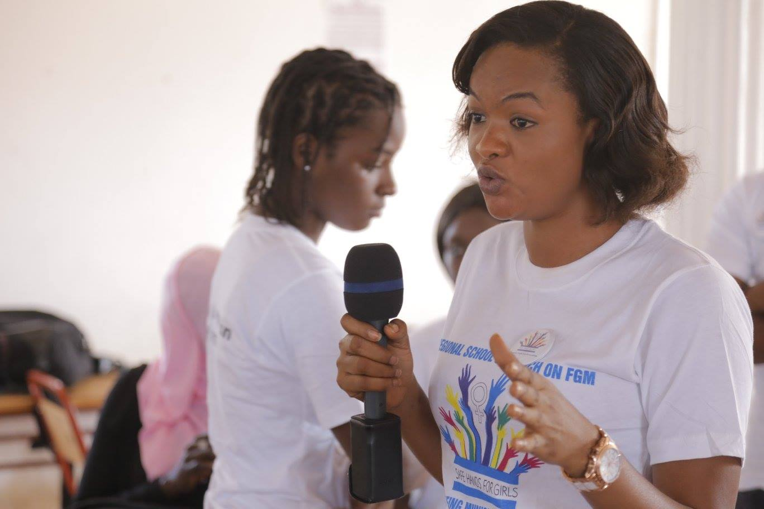

***Mam Lisa Camara***

**Statement by: Wilson F. Okoi**

Wilson F. Okoi did the introduction on what the NGO – SH4G is. He stated that Safe Hands for Girls is a survivor led Non-governmental organization that works on the eradication of Female Genital Mutilation and other forms of harmful traditional practices. The founder – Jaha Dukureh was also put into the picture. He also emphasized on why we decided to do the outreach and, what we will talk about in the subsequent minutes, questions and answers of all sorts as well. He concluded by inviting Marie Bass Gomes, a midwife to present on the health effects of FGM.

**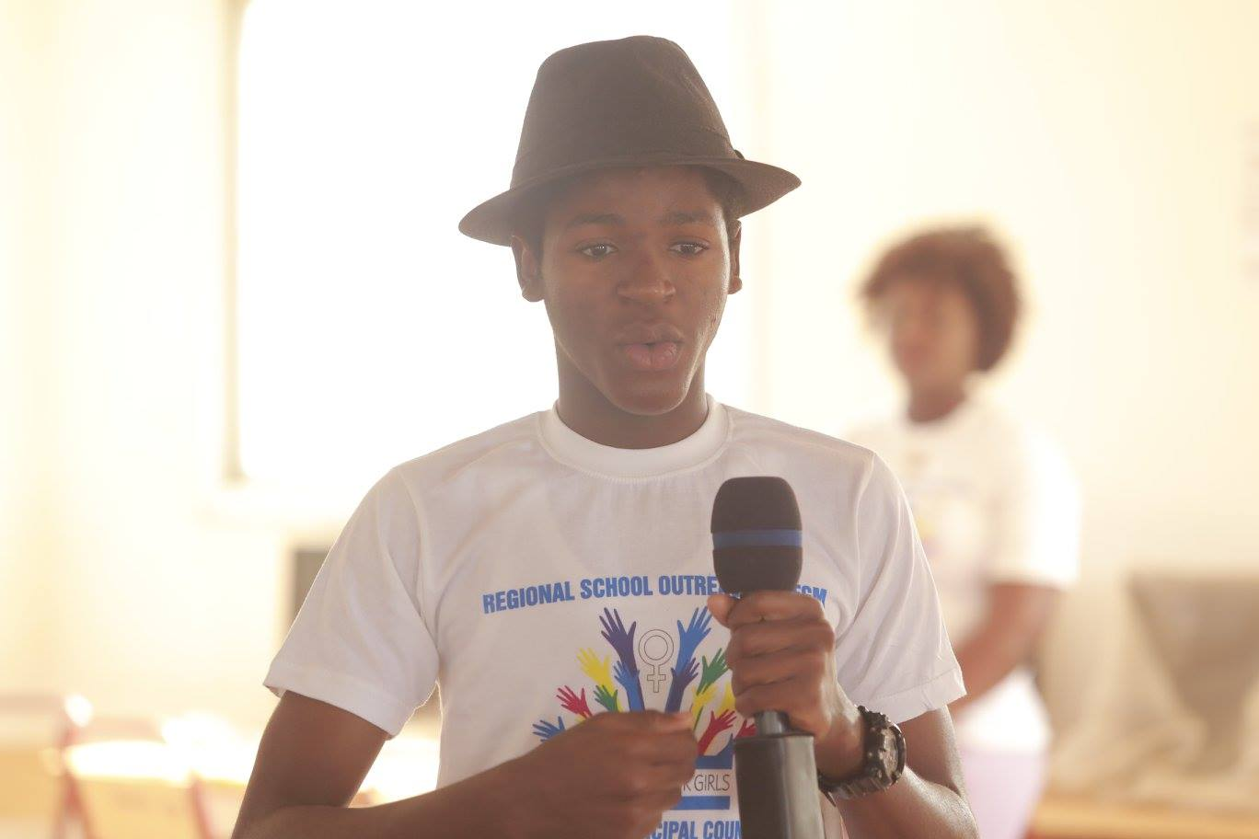**

***Wilson F. Okoi giving a brief synopsis of what Safe Hands is,***

**Presentation by: Marie Bass Gomes**

Marie Bass Gomez introduces the ‘health care’ topic by stating that only facts shall be made reference to during the course of the discussions. Mrs. Gomez defines what FGM/C is. She defined FGM as the '' partial or total removal of the female genital ''. She goes further to state some of the harmful effects of the practice of FGM which includes: -

1. Traumatic effects
2. The risk of STTD’s
3. Creation of psychological trauma due to severe pains
4. Poor vaginal lubrication due to the cutting of the Labia Minora.

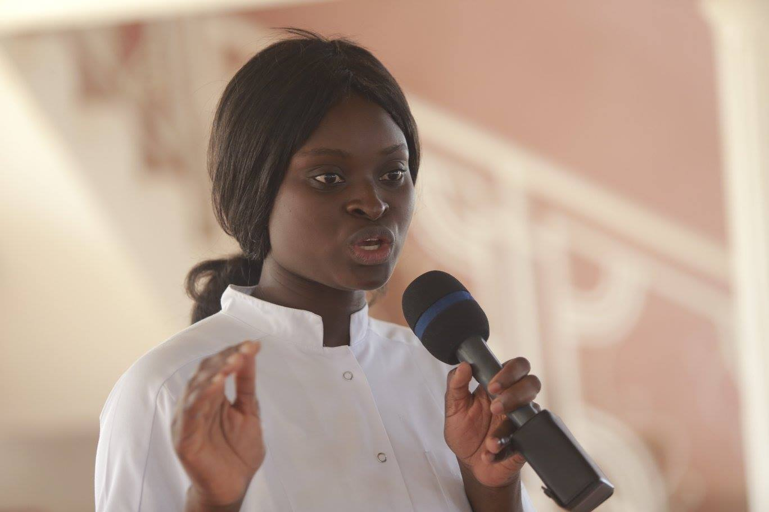

***Marie Bass Gomes, presenting on the health effects of FGM.***

**Presentation by: Maria Saine**

The next person to give a presentation was Maria Saine. She presented on the law criminalizing FGM and the legal implications against FGM. Maria Saine extends greetings to the students and starts off by asking students whether they heard about the Presidential declaration banning FGM to which majority of the students were affirmative. She further spoke about the fact that after the Presidential declaration, the National Assembly drafted a Bill which was accented to last year i.e. 2015. Maria states that the law on FGM is particular to three areas: -

1. Prohibition of Female Circumcision
2. What Female Circumcision includes
3. Accomplices to Female Circumcision

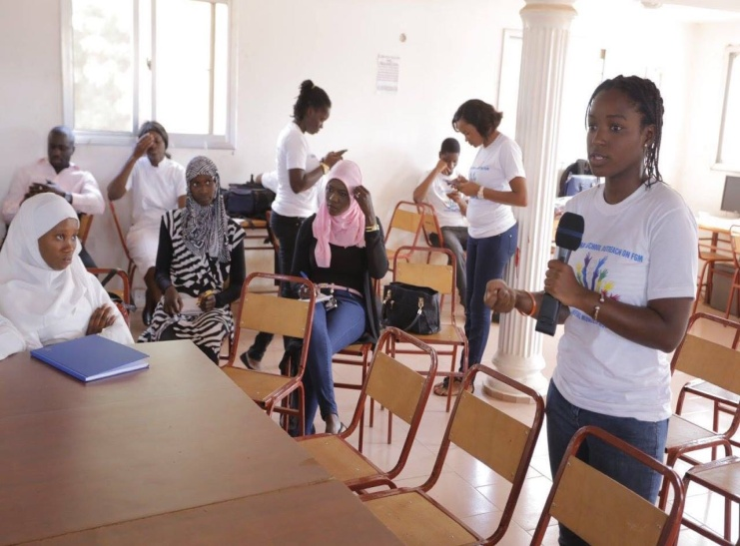

***Maria Saine, presenting on the law and legal implications of FGM.***

Maria further defines FGM as per the law, delves into the penalties as well as the law with regards to FGM leading to the death of a person. She states that as per the law, if anyone commits the act of FGM, that person will be liable for a fine of fifty thousand dalasi or serve a jail term of three years, or both. If the child dies as a result the act of FGM, that person will serve a jail sentence of life imprisonment.

Maria reminds the school students they have a duty to report anybody found committing the act of FGM. She further states that failure to report any case, and aiding, abetting or inciting someone to perform the act amounts to a fine of D10,000. Maria concluded by urging students to take it upon themselves to report any case and avoid breaking the law

Lisa Camara invites Lamin K. Saidy to present on Child Protection and FGM.

* Lamin extends greetings to all and reiterates that despite the fact that some students present may have undergone the practice of FGM, the students must however not be discouraged as all they need to do is to put an end to FGM as a practice within our generation rather than worry and regret.
* Lamin K. Saidy further speaks on Child Protection by making reference to the Children’s Act which prohibits any cultural practice that is harmful to the life of a child.
* Lamin K. Saidy concludes by stating that FGM has to be abolished as it compromises the healthy state of any girl child. Article 19 of the Children’s Act is further made reference to which promotes and protects the safety of a child. -

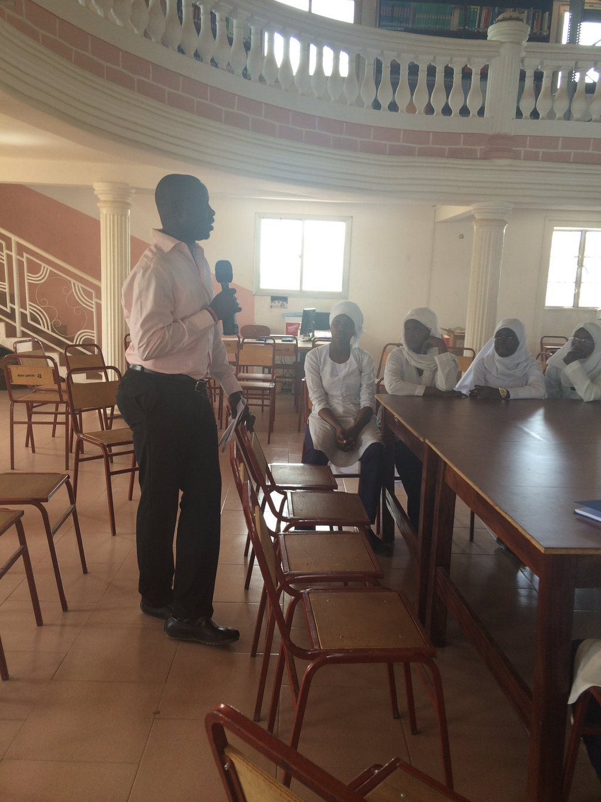

***Lamin K. Saidy presenting on child protection***

Plenary Sessions were conducted in all schools which was followed by a group photo

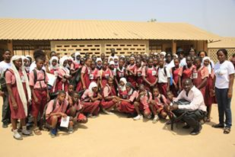

***Abuko Upper Basic School***

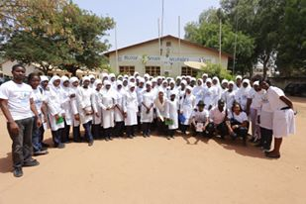

***Nusrat Senior Secondary School.***

ANNEX ONE: PICTURES DURING THE REGIONAL SCHOOL OUTREACH.

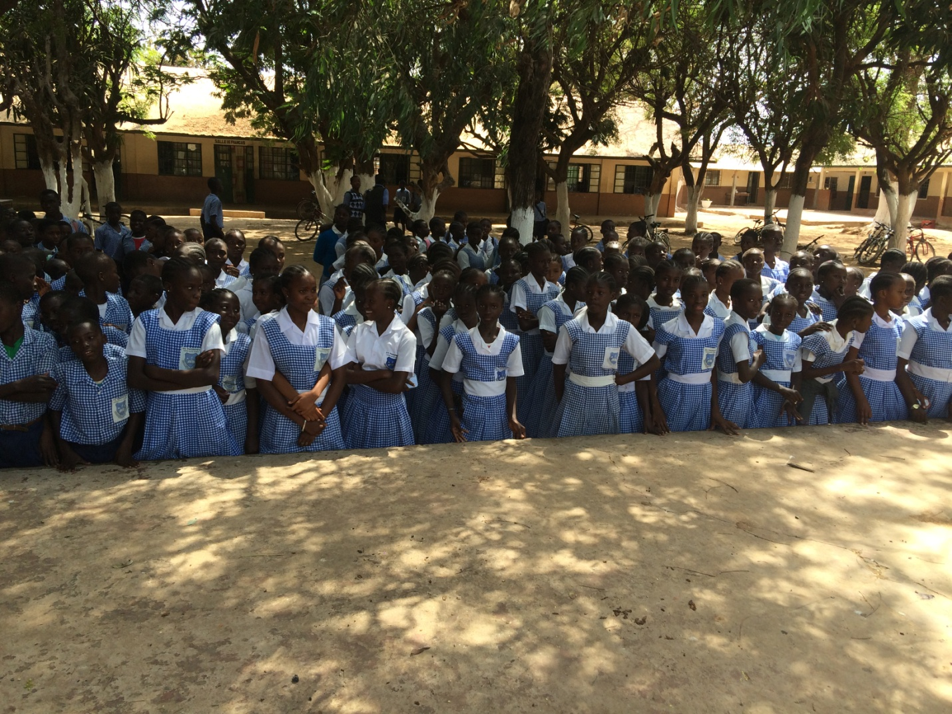

***St Therese's Upper Basic School.***

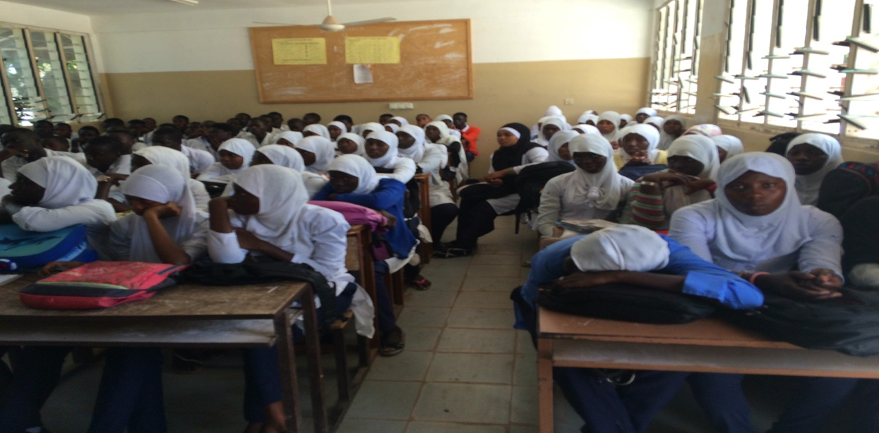

***Daddy Jobe Comprehensive Senior Secondary School.***

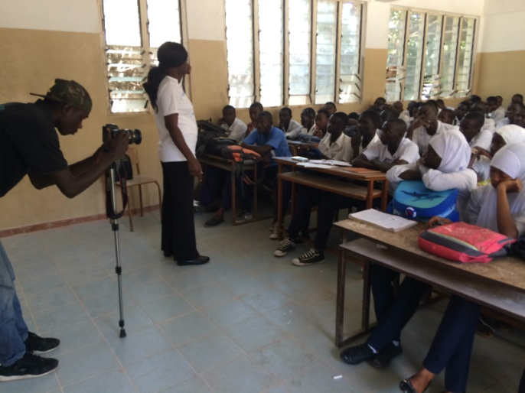

***Marie Bass presenting at Daddy Jobe Senior Secondary School.***

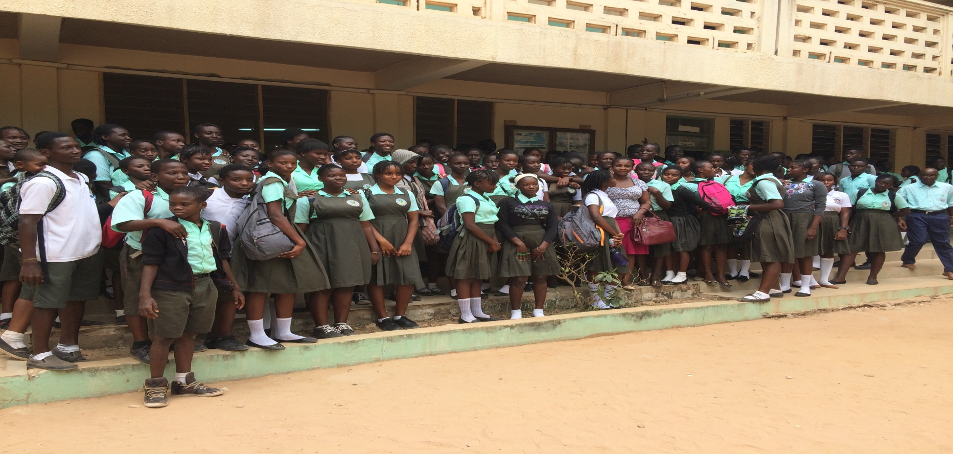

***Glory Baptist Junior and Senior Secondary School.***

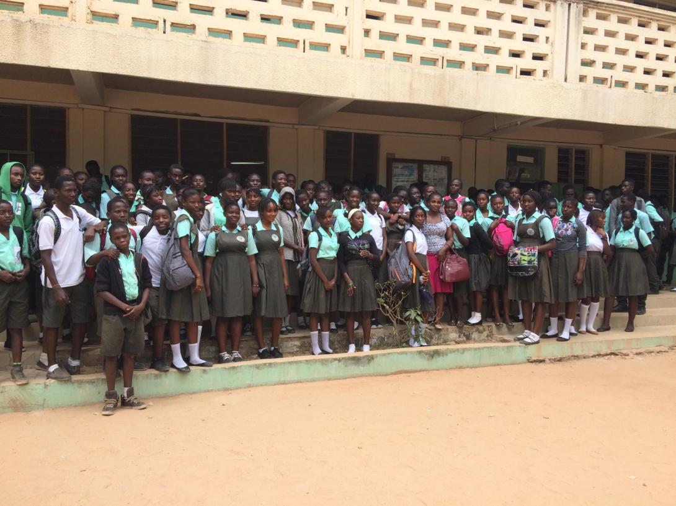

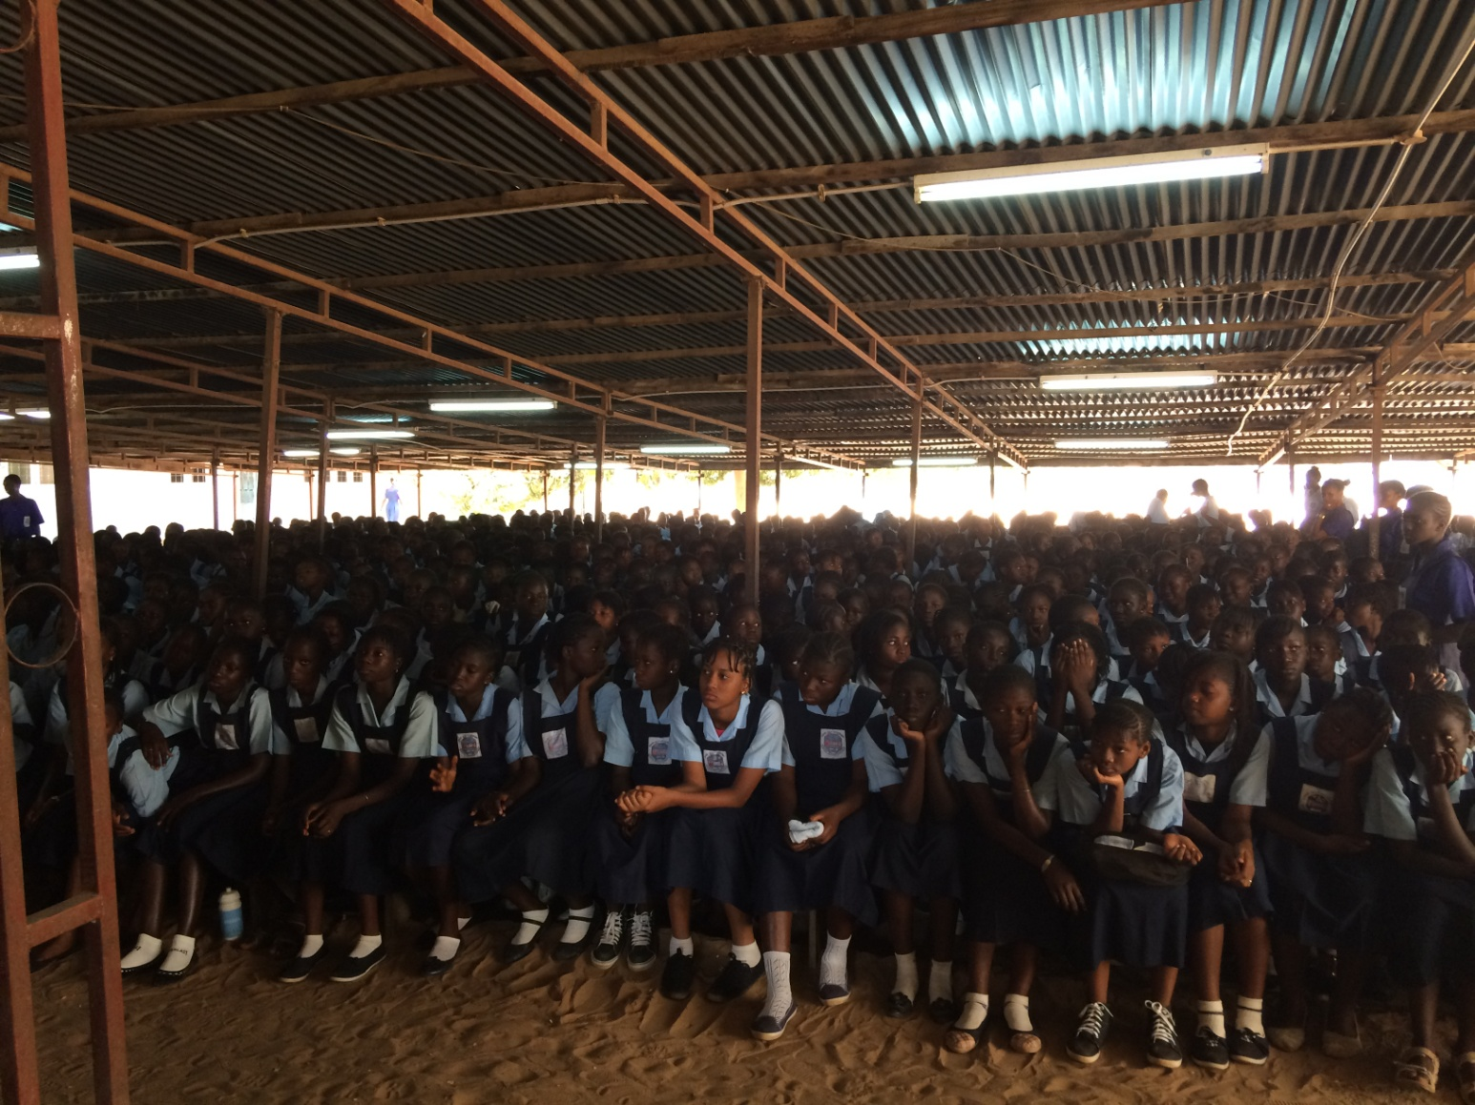

***July 22nd Junior & Senior Secondary School.***

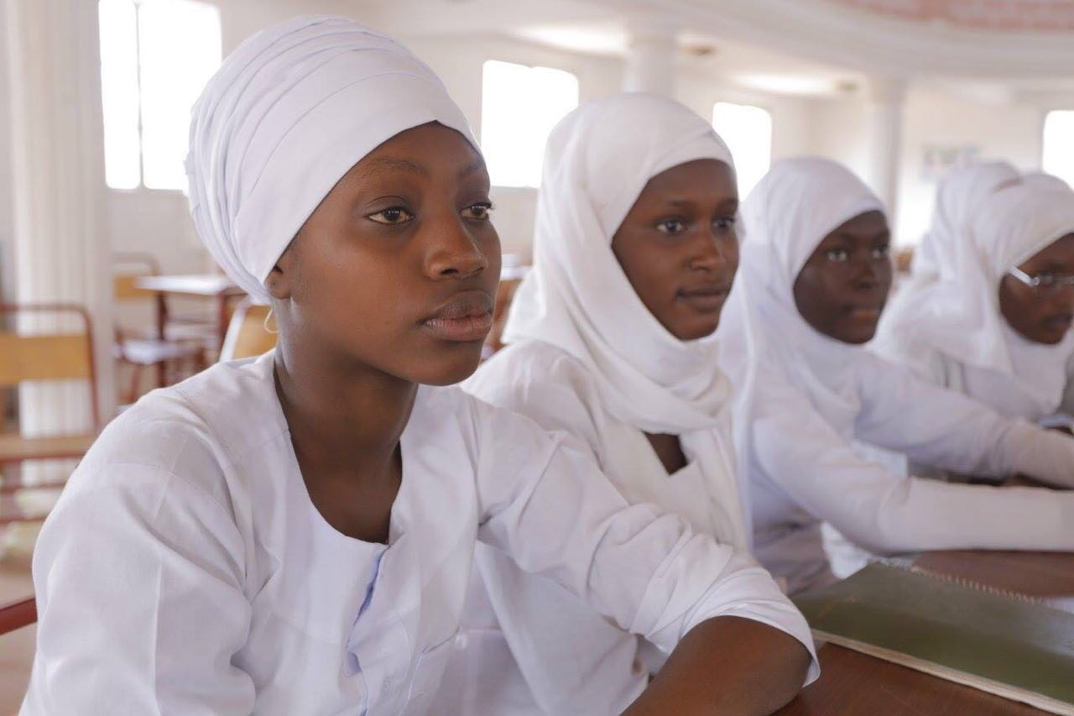

C:\Users\Maria\AppData\Local\Microsoft\Windows\INetCache\IE\USTG9S2U\13123052_1203232396356012_5672191423553036544_o[1].jpg

***Students from Nusrat Senior Secondary School.***

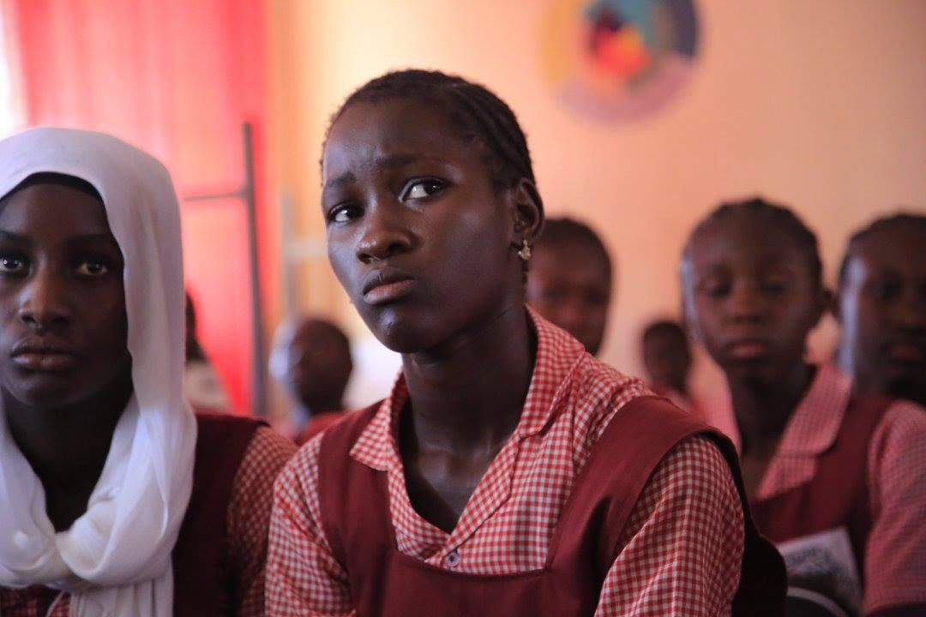

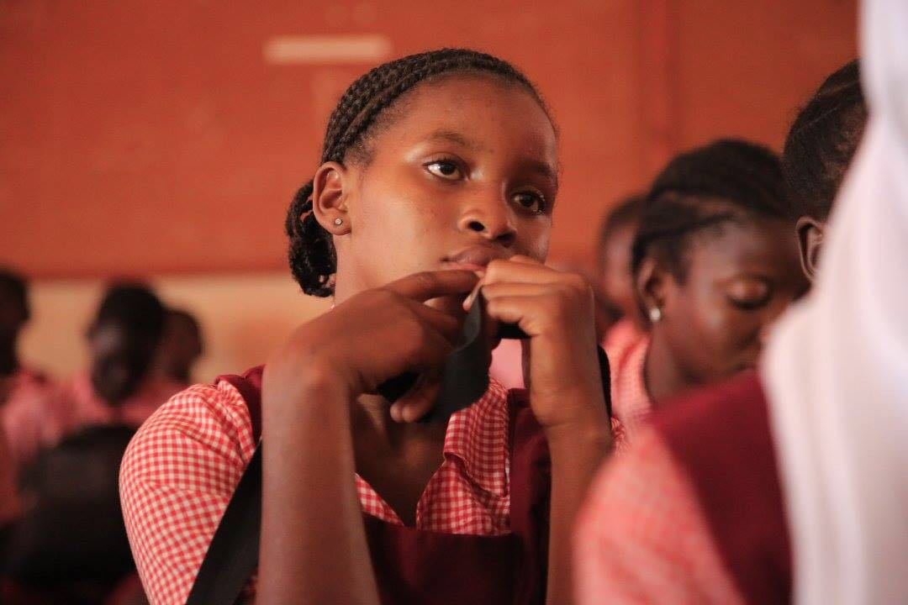

***Students from Abuko Upper Basic School.***

**LIST OF VOLUNTEERS**

|  |  |
| --- | --- |
| **NAME** | **ORGANISATION** |
| **Mam Lisa Camara** | **SHfG** |
| **Lamin K. Saidy** | **SHfG** |
| **Maria Saine** | **SHfG** |
| **Mohammed Dibbassey** | **SHfG** |
| **Tida Njie** | **SHfG** |
| **Wilson Okoi** | **SHfG** |
| **Isatou Suwareh** | **SHfG** |

**WAY FORWARD**

The outreach in region one will be followed by a Drama and Poetry competition between schools. Peer groups were also formed during the outreach. After all regions have been covered, all groups will be brought together to discuss the way forward on how they can be part of the campaign to end FGM. Trainings will also be organized for all peer groups