SCHOOL OUTREACH ON FGM AND ADVOCACY
July 11th-July 14th, North Bank Region, The Gambia

ORGANIZED BY SAFE HANDS FOR GIRLS
FUNDED BY UNICEF
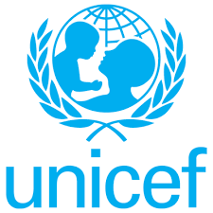

Contents
ACKNOWLEGDEMENT
INTRODUCTION
LIST OF SCHOOLS VISITED
Albreda: Aji Fatou Bojang Senior Secondary School
Essau Senior Secondary School
Kuntaya Primary and Upper Basic School
Kuntaya Senior Secondary School
Kerewan Upper Basic and Secondary School
Anglican Mission Upper Basic School
Farafenni Upper Basic School
Ngayen Sanjal Upper Basic School
Farafenni Senior Secondary School
Njaba Kunda Upper Basic School
Photos

ACKNOWLEDGEMENT
This activity is designed to create awareness about Female Genital Mutilation and its harmful effects targeting students in junior and senior secondary schools around the country, this report covers the North Bank Region (NBR) campaign.
We express our sincere gratitude to UNICEF for funding and partnering with us and our regional representatives. We also thank the Safe Hands for Girls team and the individuals who had the courage to step up and volunteer.
Appreciation is extended to the religious leaders and health personals for their presentations.
Appreciation is also extended to all the students, teachers and principals for their participation and contribution.
We also thank Fatoumata J. Newlands for compiling and drafting the report.

EXECUTIVE SUMMARY
The United Nations Children’s Fund (UNICEF) is a United Nations programme in New York that provides humanitarian and developmental assistance to children in developing countries. UNICEF protects and defends the rights of children across 190 countries.
Safe Hands for Girls is a survivor led women’s organisation that aims to eradicate Female Genital Mutilation and all other forms of Gender Based Violence through advocacy programs, trainings, workshops and community outreach, as well as to provide support to women and girls who are survivors. Safe Hands for Girls was established in 2013 with offices in the U.S. and The Gambia.

INTRODUCTION
Female Genital Mutilation (FGM) is a deeply rooted tradition practiced in The Gambia by different ethnic groups throughout the country in all regions. Despite this harmful practice people believe that FGM is a religious practice and that it is obligatory. This results up to severe long-term sexual and reproductive health effects as well as social and psychological effects that can deeply affect their lives.
As a result, Safe Hands for Girls with support from UNICEF organized a School Outreach on FGM and Advocacy as part of its agenda items to end FGM. The school outreach is for students mainly between 12- 19 years of age, specifically those in the Upper Basic School and Senior Secondary Schools. This will enable them to build advocacy skills that will help contribute in the Anti-FGM Campaign. The campaign captured more than 2000 students over roll from 10 different schools in the region, both male and female with teachers. The school outreach program is the first phase to a comprehensive National school sensitisation activity designed to educate young people on FGM, Child Marriage, Teenage Pregnancy and all other forms of child abuse. in the second and third phases, students are trained on advocacy and guided on how to form school clubs in their various schools.
OBJECTIVES
- Encourage the students to take part in the advocacy campaign against FGM.
- To sensitize students to have an overall understanding on the effects of FGM.
- Popularization of the Anti-FGM law.
EXPECTED OUTCOMES
- Get children to form school clubs/peer groups and join the Anti-FGM Campaign.
- That there is awareness on the legal implications against Female Genital Mutilation.
This report highlights what was presented and recommendations made on FGM, as well as photos taken during the school outreach.

Opening
Upon arrival in every school, the principal or vice principal introduces the Safe Hands for Girls (SHfG) team and purpose of the visit.
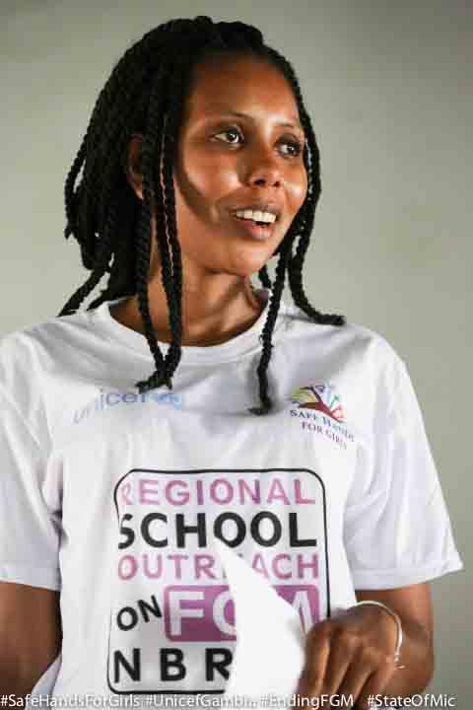
Jaha Dukureh, the founder and Executive Director of SHfG gave a brief description of SHfG and narrated her story as a survivor of FGM and Child Marriage. She persuaded to gather as much information as they can to go back and sensitize their communities to help stop these harmful traditional practices. J
Jaha talked about her work as an activist in the Gambia and around the world and how it is the responsibility of every Gambia to protect the children.

Jaha Dukureh
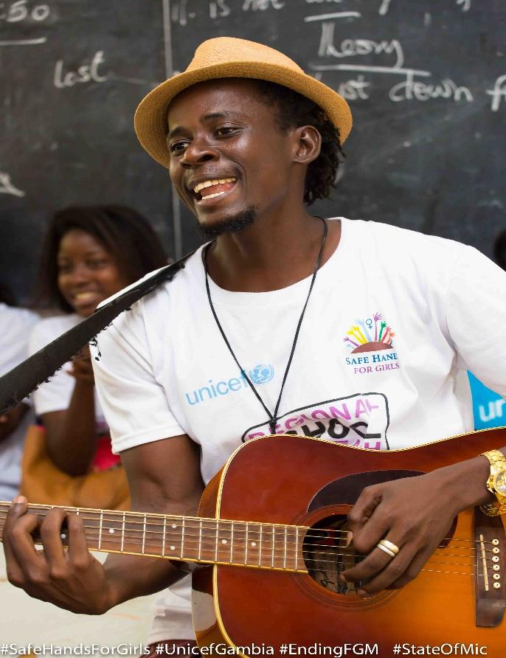
There was a musical interlude performed by Barhama Cham, an artist who is part of the “Kerr Gi Family” group, Barhama joined the team on the trip to ad his voice in the campaign through his music, he believes Musicians have an important role to play in the fight and messages can be put across through entertainment. There was a musical interlude after every speaker, students enjoyed the momentum and learnt from speakers in the process.
Barhama performed one of his songs called “Say No”. - which talks about FGM and early marriage.
Barhama Cham - Artist

Topics covered - Medical
Definition of Female Genital Mutilation
The disadvantage of FGM;
- Childbirth complication
- Excessive bleeding
- Infection which can lead to cervical cancer.
- It can lead to rectum disorder.
- It can also lead to birth complications.
- It can lead to haemorrhage.
- Q&A

Topics covered: Religion
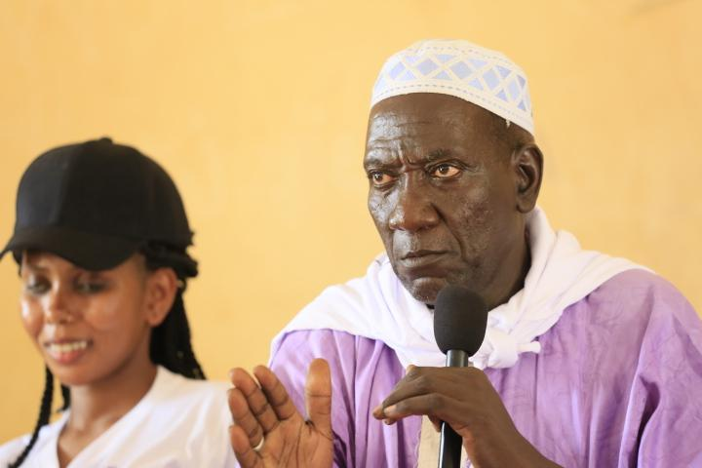
Usthas Jassey greeted. He made a clarification that FGM is not an obligatory practice in Islam neither is it a Sunnah.
Quotations;
- “FGM is not obligatory.”
- “Do not harm yourself, for thy have created you and for thy have mercy on you.”
- The hadiths - misinterpretation
- Misconceptions of religion and Islam
He concluded that the FGM is “Makramah” which means an act done out of appreciation.
Usthas Jassey

Topics Covered: Law
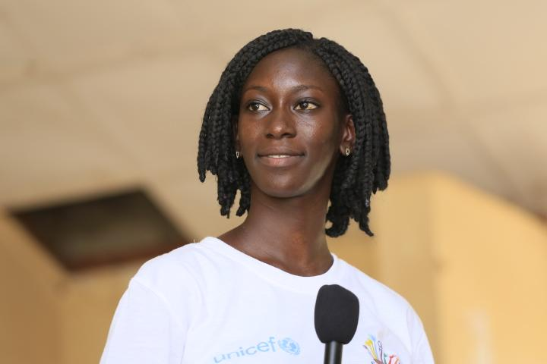
Awa Gai, an intern at SHfG and a law student at the University of The Gambia facilitated the law aspect.

- The FGM act
- The domestic and international laws
- penalties and prosecution
- Clarification of the law not being a jammeh law
- Q&A

Awa Gai - Law student

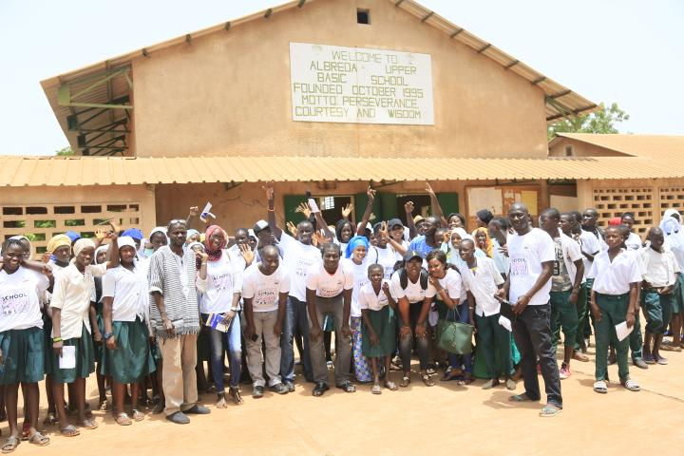
ESSAU – ESSAU SENIOR SECONDARY SCHOOL
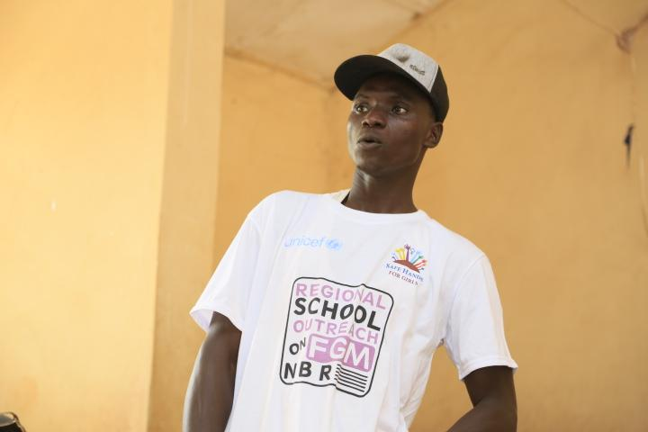
Yunusa Suwareh - Student during Q&A

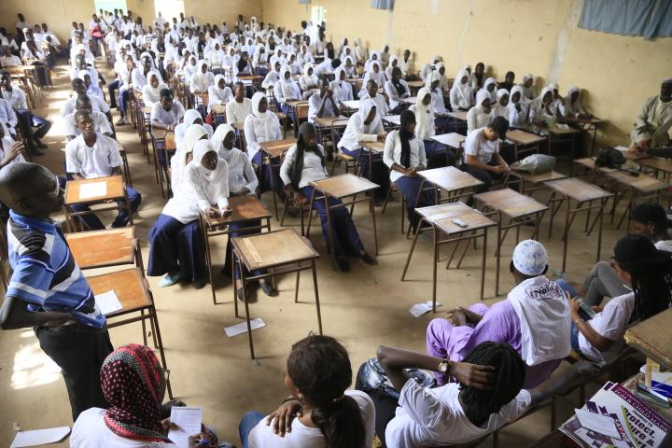
Kuntair Upper Basic School
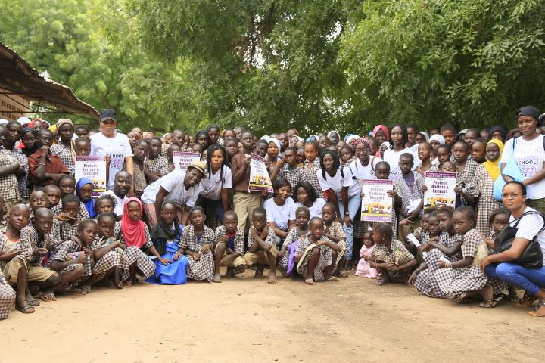
Kuntair Senior Secondary School

Visit by our funding partners - UNICEF
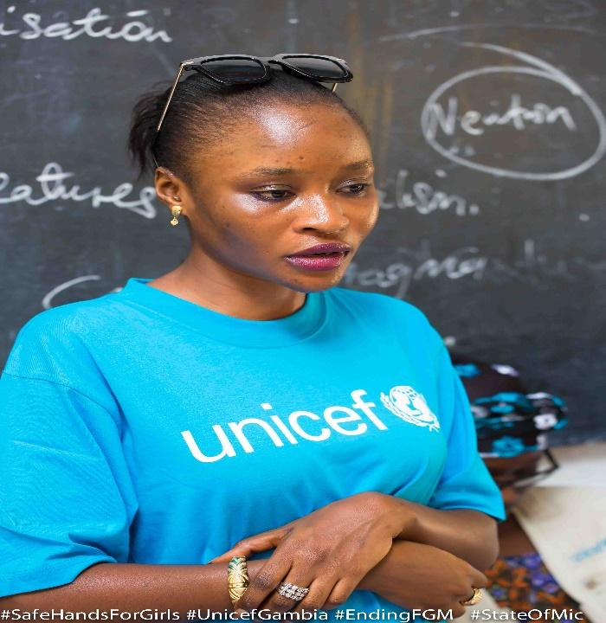
Ramou Sonko, Child Protection Officer of UNICEF greeted introduced herself and her colleagues, Jama Jack and Lama Barrow. She thanked SHfG for partnering with them, encouraged the students to sensitize their societies about the harmful practices such as FGM. She elaborated on other issues such as child marriage and domestic violence that should also be taken into consideration.

Ramou Sonko
“A society that fails to protect its children is a failed society therefore, I pledge to protect myself, my family and the society at large from female genital mutilation.”
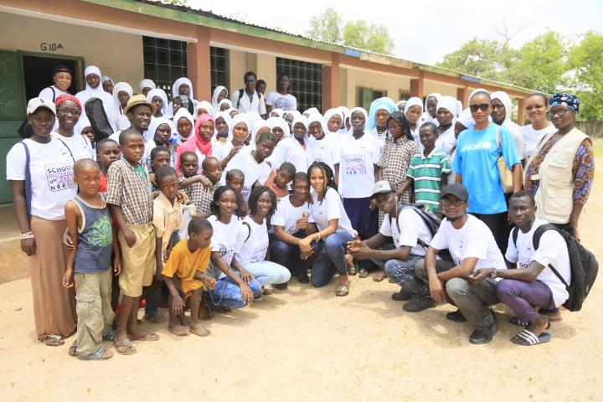
KEREWAN – KEREWAN BASIC CYCLE SCHOOL
Farafenni Anglican Mission Upper Basic

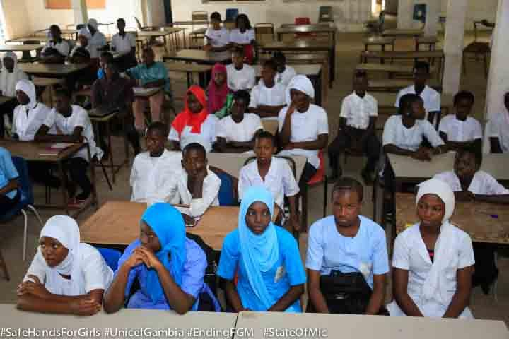
FARAFENNI – FARAFENNI UPPER BASIC SCHOOL
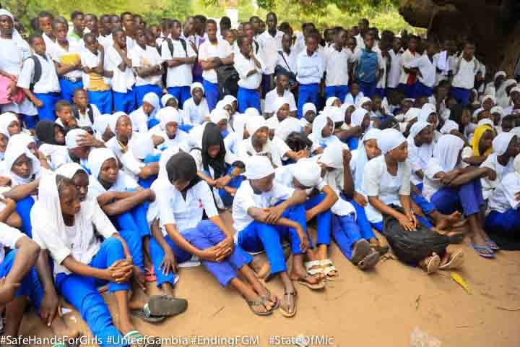
NGAYEN SANJAL – NGAYEN SANJAL UPPER BASIC SCHOOL
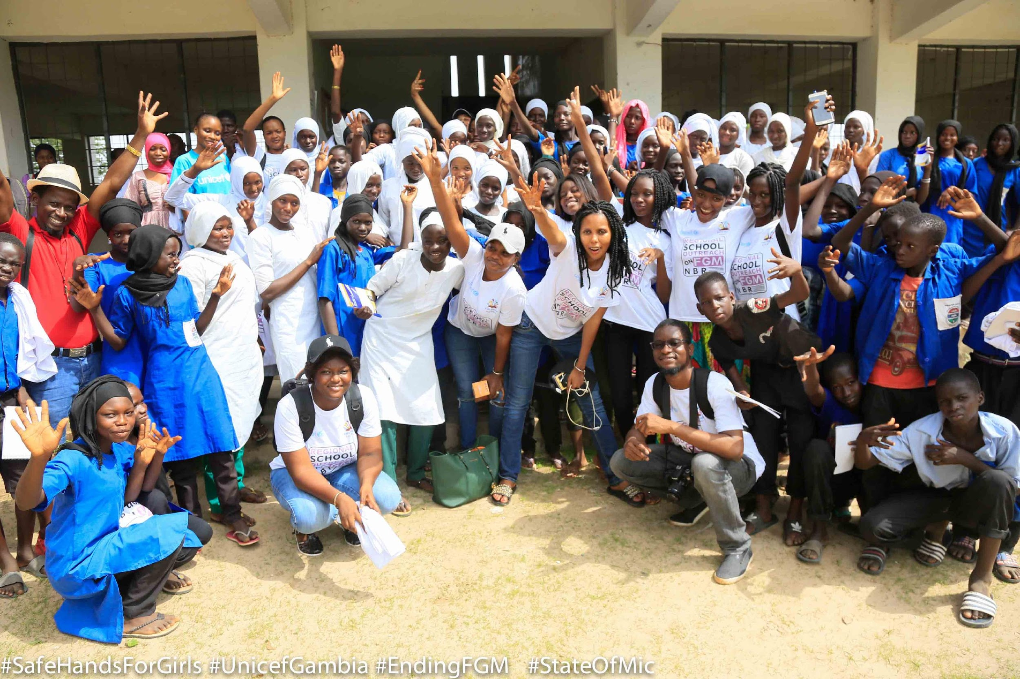
FARAFENNI – FARAFENNI SENIOR SECONDARY SCHOOL
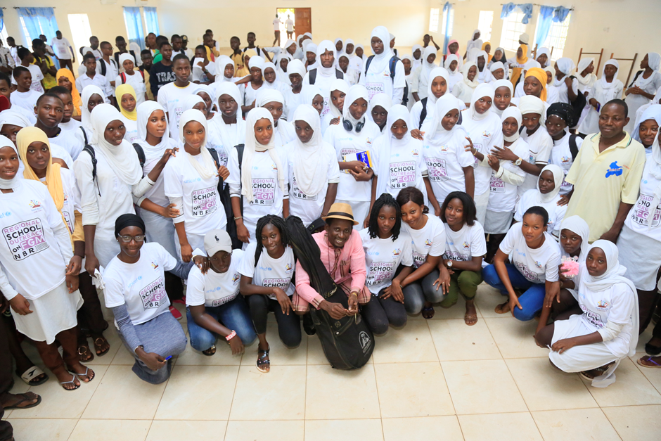
NJABA KUNDA - NJABA KUNDA UPPER BASIC SCHOOL AND SENIOR SECONDARY SCHOOL

PHOTOS
The Safe Hands for Girls Team.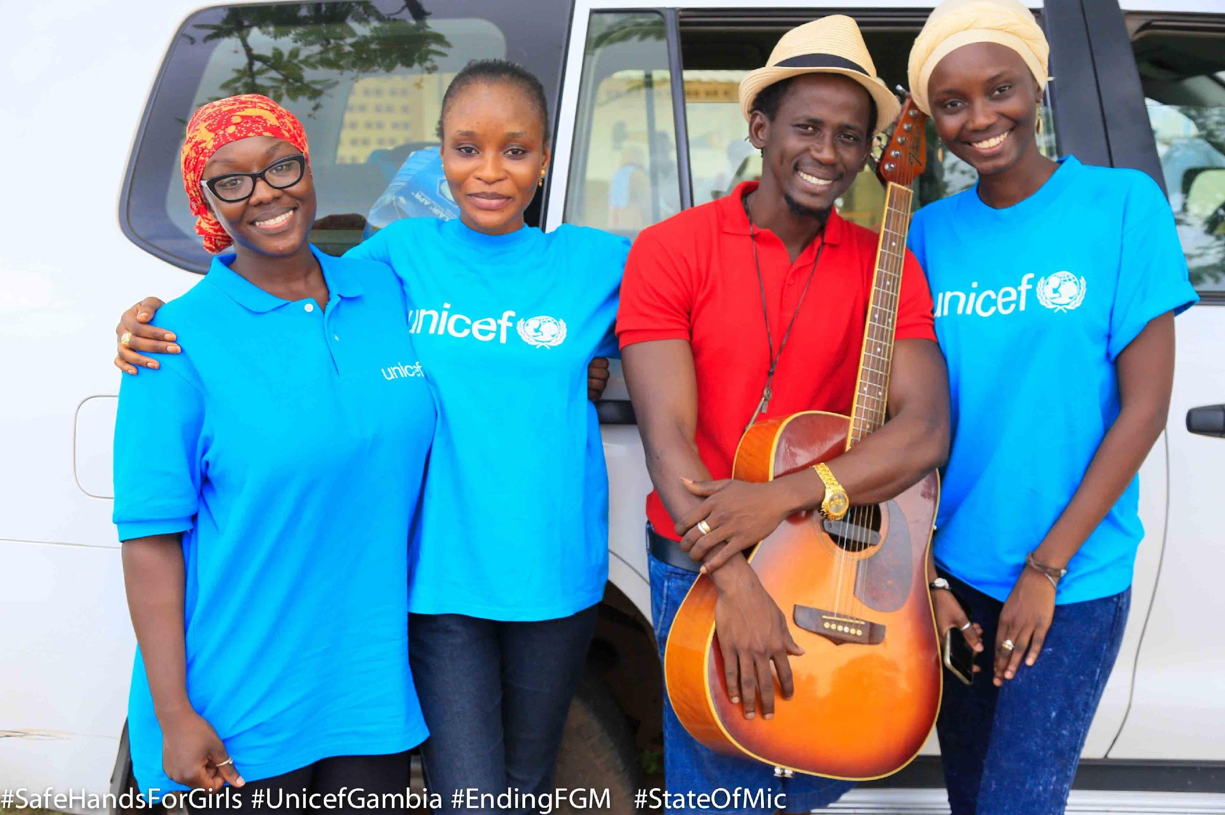
The UNICEF Team with Barhama Cham.

